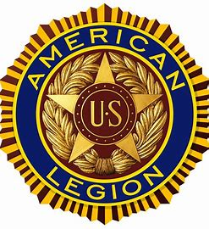

**American Legion Meeting Minutes**

**April 12, 2025**

1.    Meeting Started at 10:08 hrs.

2.     The Pledge of Allegiance was said by all.

3.    **OPENING PRAYER** – John McGuire gave the opening prayer

4.    LEGION CREED – Legion Creed was said by all

**5.**   **POW/MIA Empty Chair –**The POW/MIA Empty Chair ceremony was conducted per Resolution 288

**6.**   Meeting was declared and Roll Call/Attendance was conducted.

7.    **MINUTES APPROVAL –**Minutes for March 15 unavailable.

**8.**   **TREASURER REPORT –** No Report , Ray not present.

**9.**   **We owe County money according to the County**

10.                   **Membership and Dues – Rainer- We have gotten some dues, and will provide to Ray.**

11.                   Rainer, next meeting May 10.

12.                   Rainer, County meeting, April 25, 8pm. At Glenwood Landing 336. 190 Glen Head Rd, Glen Head, NY 11545.

13.                   Rainer;  We will meet with NHP Herald Newspaper

to discuss recruitment and what the American Legion is all about**.**

**14.**                   **Fr. Fink of  Holy Spirit/Notre Dame is a Vietnam Veteran.**

**15.**                   **Vets restore Plan –**

**LI Cares, LI State Vets Home Huntington**

**Chamber of Commerce Listing, Rainer will check it out as well**

**As Liberty Passes, State Park and Golf Courses.**

**Event  –  Oct. 19 2025**– Post Birthday Luncheon.   This years Post Birthday Dinner will be held at Gino Restaurant, 1113 Jericho Turnpike, New Hyde Park NY**.**

**Event – Applebee’s Pancake Breakfast Nov. 15 or 16.**

**Meeting ended 11:34am.**